SOFTWARE REQUIREMENTS SPECIFICATIONS

PROJECT: VEHICLE TRACKING USIMG DRIVER MOBILE GPS TRACKING

PRESENTED BY:

1.Gubba Jagadeesh(2203031240439)

2.U.Tarun kumar(2203031241355)

3.Harsha Vardhan(2203031241299)

4.Teja(2203031241265)

1.Introduction:

Vehicle tracking refers to the process of monitoring the location and movement of a vehicle in real-time using GPS (Global Positioning System) technology. It is primarily used for fleet management, logistics, and personal vehicle monitoring. Through the use of GPS tracking devices, which are installed in vehicles, users can track the vehicle's position, speed, and route on a digital map.

Key aspects of vehicle tracking include:

1. **Real-Time Monitoring**: Allows fleet managers or vehicle owners to monitor the vehicle's location and movement in real-time.
2. **Data Collection**: Provides data about the vehicle's speed, fuel consumption, mileage, and even the driver’s behavior.
3. **Security**: Enhances the security of vehicles by providing tracking data in case of theft or unauthorized use.
4. **Route Optimization**: In fleet management, vehicle tracking helps in optimizing routes for fuel efficiency and timely deliveries.
5. **Geofencing**: Setting up virtual boundaries that alert the vehicle owner or fleet manager if the vehicle enters or exits a predefined area.
6. **Maintenance Alerts**: Some tracking systems can provide notifications for routine maintenance or when a vehicle is due for servicing.

Vehicle tracking is used by a wide range of industries, from logistics companies to ride-sharing services, to enhance safety, improve operational efficiency, and reduce costs.

**2.Analysis:**

Vehicle tracking systems offer significant benefits, including improved efficiency, cost reduction, enhanced security, and better driver behavior monitoring. They allow businesses to optimize routes, reduce fuel consumption, and recover stolen vehicles. However, challenges such as privacy concerns, high initial investment, and reliance on internet connectivity can be barriers.

Key trends include the integration of telematics, AI, and IoT for more comprehensive insights and predictive maintenance. Overall, vehicle tracking helps businesses save costs and improve operations, but addressing privacy and technical limitations is essential for maximizing its potential.

**Advantages:**

1. **Improved Efficiency:** Vehicle tracking helps optimize routes, reducing fuel consumption and improving delivery times. It enhances operational efficiency, especially in logistics and fleet management.
2. **Cost Reduction:** By monitoring fuel usage, idle times, and driving behavior, businesses can lower operational costs, such as fuel expenses and maintenance costs.
3. **Security:** Real-time tracking enables quick recovery of stolen vehicles. Features like geofencing provide alerts if a vehicle enters or exits a specific area, enhancing security.
4. **Driver Behavior Monitoring:** Vehicle tracking systems collect data on driver speed, braking habits, and idle times, enabling businesses to improve safety and reduce wear and tear on vehicles.

**Trends:**

1. **Integration with Telematics:** Advanced vehicle tracking systems are integrating telematics to provide detailed vehicle diagnostics and performance data, enabling better maintenance scheduling.
2. **AI and Predictive Analytics:** AI is being used to predict maintenance needs, traffic patterns, and driver behavior, enhancing decision-making and operational planning.

3. FUNCTIONAL REQUIREMENTS **:**

1. **Real-Time Location Tracking**: Provides live updates on driver’s location.
2. **Route Optimization**: Suggests the most efficient routes to save time and fuel.
3. **Driver Behavior Monitoring**: Tracks driving habits like speed, braking, and idling.
4. **Geofencing Alerts**: Sends notifications when the driver enters/exits specific areas.
5. **Trip History & Reports**: Logs past trips and provides performance data.
6. **Real-Time Notifications**: Alerts for speeding, harsh braking, or detours.
7. **Maintenance Reminders**: Notifies about upcoming vehicle maintenance.
8. **Fleet Integration**: Syncs with fleet management software for comprehensive tracking.
9. **Fuel Monitoring**: Tracks fuel consumption and identifies inefficiencies.

4.FLOW CHART :

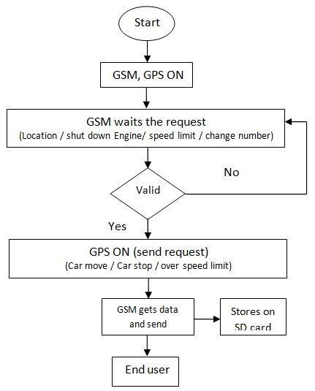

5.IMPPLEMENTING GPS TRACKING SYSTEM :

Implementing a GPS tracking system involves several stages, including planning, hardware and software integration, and deployment. Below are the key steps for successfully implementing a GPS tracking system:

**Define Objectives & Requirements**: Identify goals (fleet management, security) and list needed features (real-time tracking, geofencing, reports).

1. **Choose GPS Hardware**: Select suitable GPS devices for your vehicles, considering connectivity (cellular/satellite) and installation type (plug-and-play or hard-wired).
2. **Develop or Choose Software**: Use or develop a platform for real-time tracking, alerts, reporting, and mobile access. Ensure user-friendly interface.
3. **Integrate with Existing Systems**: Connect the GPS tracking system with current fleet management software or APIs for enhanced functionality.
4. **Data Security & Storage**: Ensure encrypted data transmission and storage, with regular backups. Comply with data protection laws.
5. **Set Up Alerts**: Configure geofencing, speed, route, and maintenance alerts to monitor fleet performance.
6. **Install Trackers**: Install GPS devices in vehicles and test functionality for real-time updates and alerts.
7. **Train Users**: Provide training for fleet managers and drivers on using the system, interpreting data, and setting up alerts.

**5.REFERENCE** :

A vehicle tracking system (VTS) refers to a technology that allows the real-time tracking and monitoring of vehicles through GPS (Global Positioning System) or RFID (Radio Frequency Identification) technology. It typically uses a combination of hardware (such as GPS devices) and software to monitor, control, and manage the movements of vehicles. These systems are widely used in fleet management, logistics, transportation, and personal vehicle monitoring.

* **GPS Receiver**: Collects location data (latitude, longitude).
* **Telematics Unit**: Monitors vehicle data (speed, fuel consumption, etc.).
* **Communication Module**: Sends data via cellular or satellite communication.
* **Tracking Software**: Displays and analyzes data on a web/mobile app.

**Key Features**:

* **Real-Time Tracking**: Shows vehicle position on a map.
* **Geo-Fencing**: Sends alerts when vehicles enter/exit predefined zones.
* **Route History**: Tracks past routes and behaviors.
* **Maintenance Alerts**: Notifies for vehicle upkeep.

**Applications**:

* **Fleet Management**: Optimizes routes and reduces costs.
* **Logistics**: Tracks deliveries and ensures efficiency.